

Cancelling Quotes & Oredrs And displaying active count for Quotes & Orders for selected group
User’s Guide
Version 1.0

Disclaimer

Copyright © 2006 Chicago Board Options Exchange. All rights reserved.
The information contained in this document constitutes confidential and/or trade secret information belonging to CBOE. This document is made available to CBOE members and member firms for use with CBOEdirect™. This document is provided "As Is" with all faults and without warranty of any kind, either expressed or implied.

Change Notices

The following change notices are provided to assist users of the SA-CBOEdirect System Administrator help-desk system in determining the impact of changes to their process.
If you have any questions or review comments about this document, please contact Odalys Castro at (312) 786-8817.

Date | Version | Description of Change
05/22/07 | 1.0 | New document.

Table of Contents
Table of Contents 3
Introduction 4
Purpose 4
Intended Audience 4
Conventions Used in this Guide 4
Help Desk Enhancements 5
Getting Started 6
Login 6
User Group Management………………………………………………………………………..7
Get order……………………………………………………………………………………………………………
Get quote……………………………………………………………………………………………………………
Cancel order…………………………………………………………………………………………………………..
Cancel quote…………………………………………………………………………………………………………..

Exit the System 13
Exit the System 13

Introduction

Purpose | This document was written to assist users in utilizing the User Group Management features of the SA-CBOEdirect System Administrator screen-based trading system. Through user group management we are able to get the information about how many orders and how many quotes are active for selected user, and also we can cancel the order and quote for that user.
Intended Audience | This user guide is intended for any person interested in SA-CBOEdirect System Administrator's User Group Management feature.
Conventions  Used in this Guide | The system was designed so that you can use the feature as a standalone application.  There are several conventions used throughout this guide to help trigger important information:
 | Bolding | Used to highlight menu selections (e.g., Login) and button names (e.g., Update)
 | Brackets [ ] | Used to highlight keyboard commands (e.g., [Alt]-[T]). Note that when [Alt] or [Ctrl] are used in conjunction with another key, hold down the first key while pressing the second.  Some button functions can be executed through keyboard commands. Hold down the [Alt] key and press the keyboard character of the underlined letter in the command. For example:  [Alt]-[R] Restores an active window

 | Help Desk Enhancements

This user’s guide will direct you through four of the User Group Managment functions for SA-CBOEdirect System Administrator.

Getting Started

 | Login to SA-CBOEDirect System Administrator.
 | 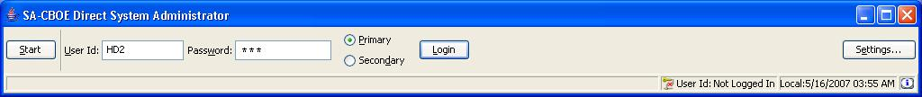
Login | Enter your User ID and Password. Both User ID and Password are case sensitive. Select your login as Primary by clicking the appropriate radio button.  Click Settings, to change your login mode. The Session Settings window will display.
 | 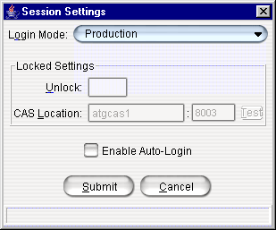
Select your Login Mode setting from the drop down list, click Submit, Confirm. If you decide you do not wish to change your login mode, click Cancel. The system will return to the menu window. Click Login.
To change your CAS location, enter your password in the Unlock field and enter the new CAS location. Click Test to check your setting. Click Submit. If you decide you do not wish to change your login mode, click Cancel. The system will return to the menu window.
Click Login. The SA-CBOEDirect System Administrator window will display.
 | 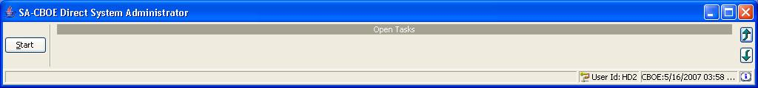
 | You are now ready to go to the User Group Managment window.
 | Select Start → User → User Group Managment → Create New Window
 | 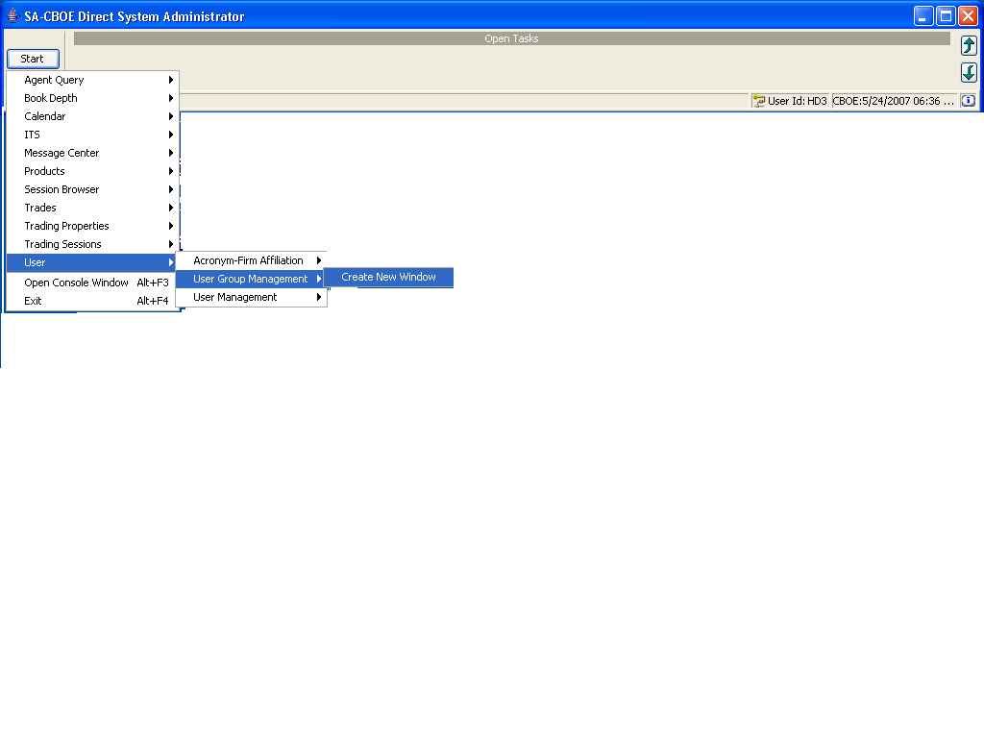

User Group Managment

 | The User Group Management allows you to Get the number of active order and quotes for selected user. It also gives the functionality of canceling the order and quote for the selected user.
 | 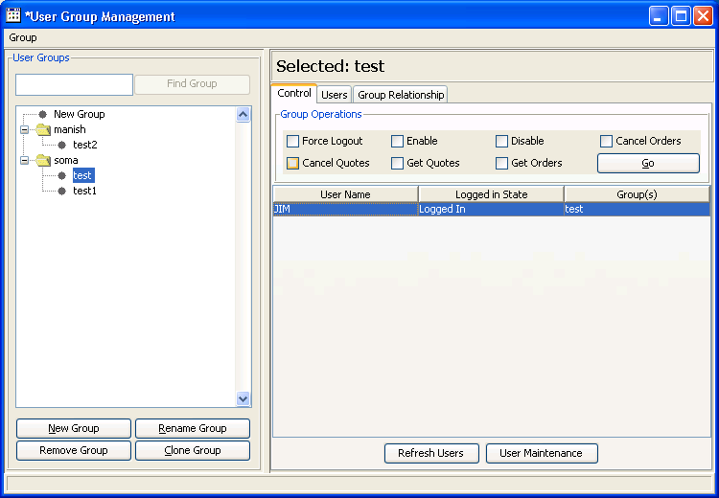
Get Order | To get the order for selected group, select the group, here test group is selected and JIM is the user who is in logged in mode.  To get the number of active order for test group select the Get Order Check Box of the right side panel and then select the Go Button.
 | 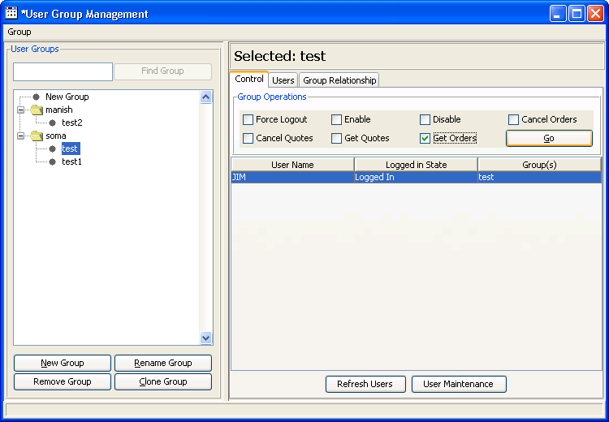
 | Following screen will get appear.
 | 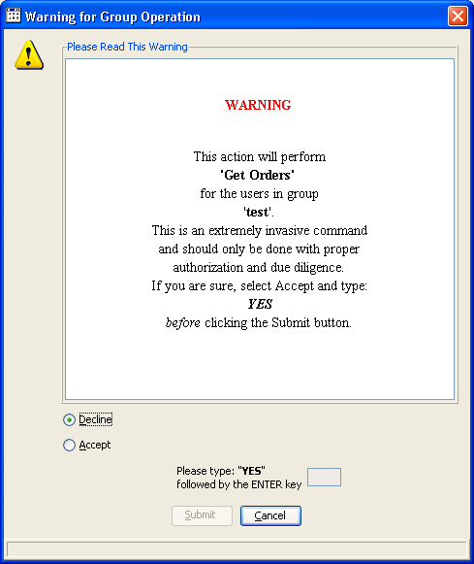
Select the Accept Radio Button and type “YES” followed by enter key.
- Now Submit Button gets enable, click on Submit.
- This changes the button to Confirm. Click on Confirm for confirming the operation.
- If you don’t wish to get the order, hit cancel.

 | 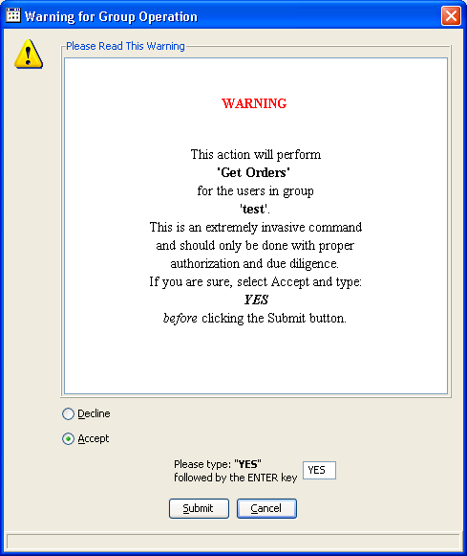
 | When we submit it will display all the Active order count for the selected group.
 | 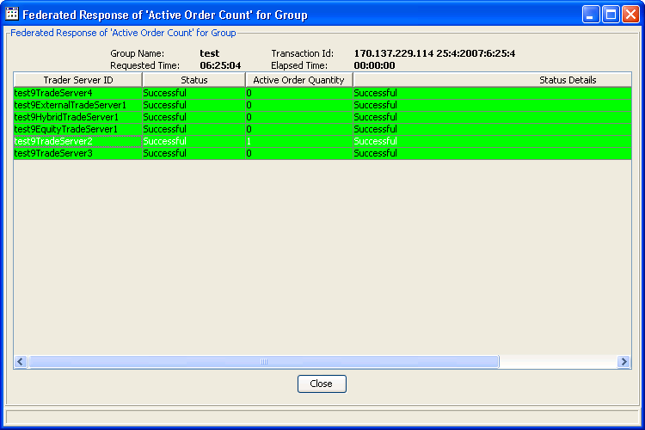
 | Select the close Button.one message window will get appear.select cancel if you don’t want to come out from the cancel order window, otherwise select ok.
 | 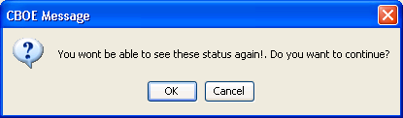
Get Quote | To get the Quote for selected group, select the group, here test group is selected and JIM is the user who is in logged in mode.  To get the number of active quote for Test Group select the Get Quote Check Box of the right side panel and then select the Go Button.
 | 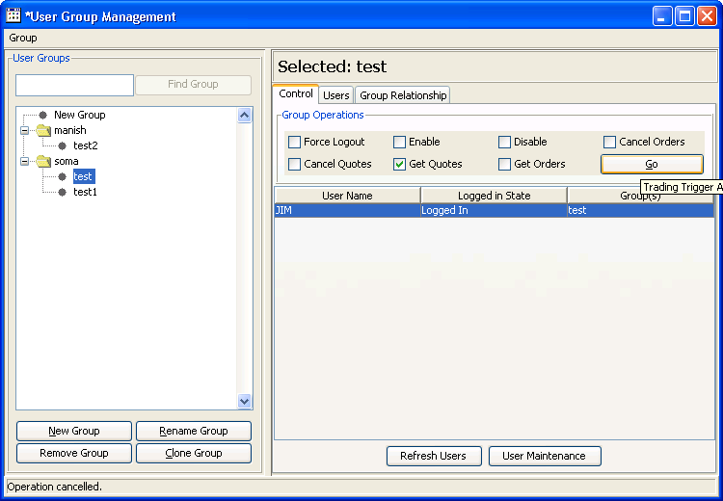
 | Following screen will get appear.
 | 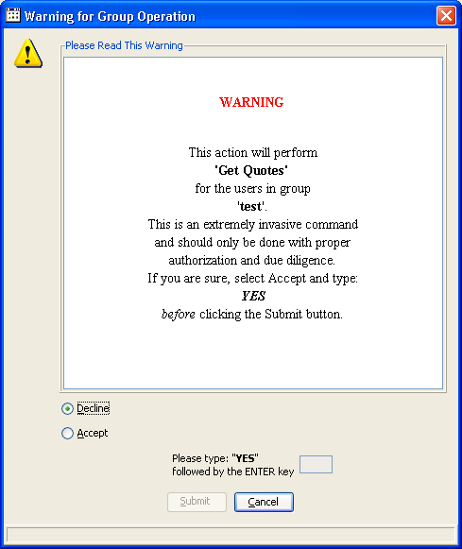
Select the Accept Radio Button and type “YES” followed by enter key.
- Now Submit Button gets enable, click on Submit.
- This changes the button to Confirm. Click on Confirm for confirming the operation.
- If you don’t wish to get the Quote, hit cancel.

 | 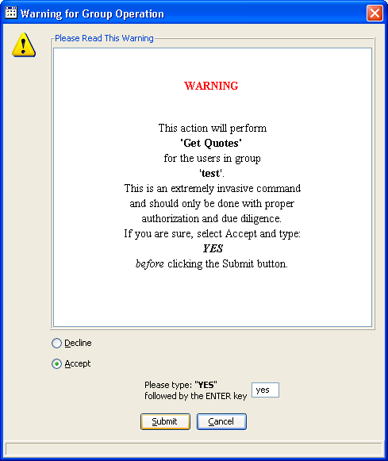
 | When we submit this it will display all the Active Quote for the selected group.
 | 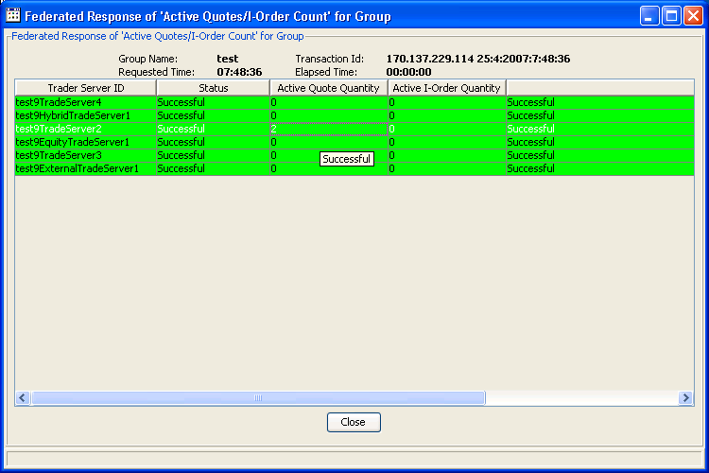
 | Select the close Button.one message window will get appear.select cancel if you don’t want to come out from the cancel order window, otherwise select ok.
Cancel Order | To cancel the order for selected group, select the group, here test group is selected and JIM is the user who is in logged in mode.  Now for Test Group select the Cancel Ordet Check Box of the right side panel and then select the Go Button.
 | 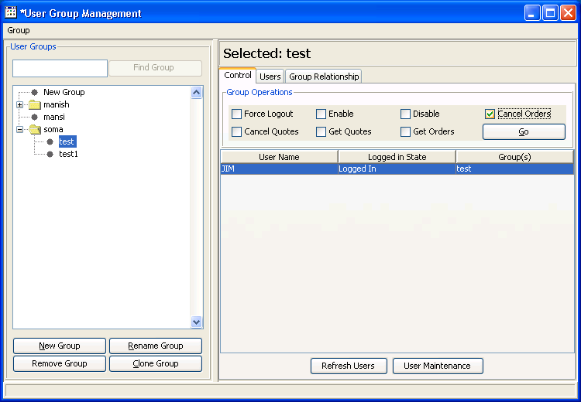
 | Following warning message window will get appear.
 | 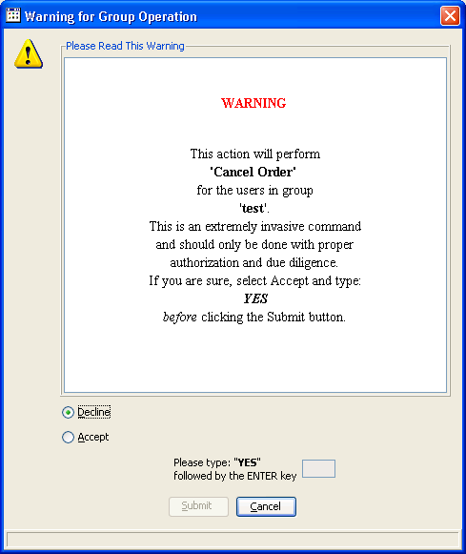
Select the Accept Radio Button and type “YES” followed by enter key.
- Now Submit Button gets enable, click on Submit.
- This changes the button to Confirm. Click on Confirm for confirming the operation.
- If you don’t wish to cancel the order, hit cancel Button.

 | Federated Respose of ‘cancel order’ for group window will come up.
 | 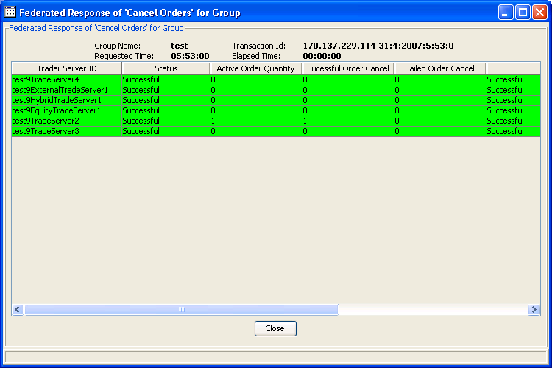
 | Select the close Button.one message window will get appear.select cancel if you don’t want to come out from the cancel order window, otherwise select ok.
Cancel Quote | To cancel the quote for selected group, select the group, here test group is selected and JIM is the user who is in logged in mode.  Now for Test Group select the Cancel Quote Check Box of the right side panel and then select the Go Button.
 | 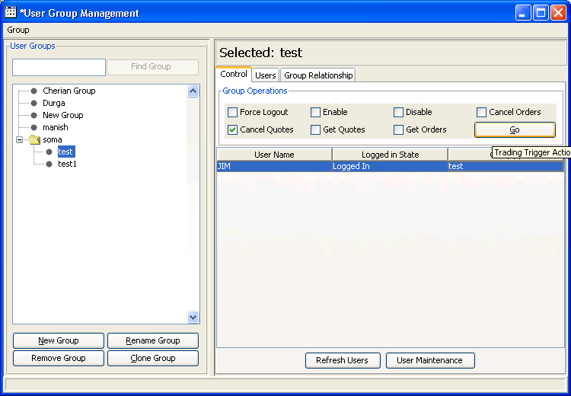
 | Following warning message window will get appear.
 | 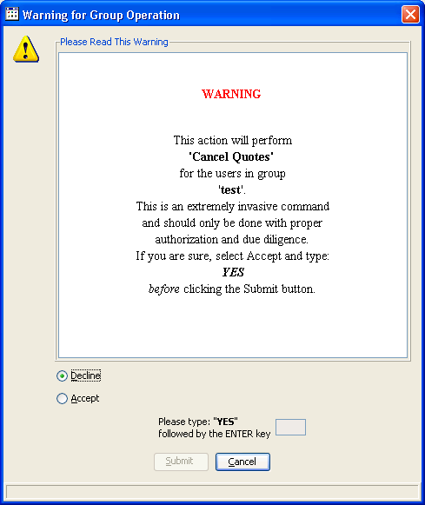
Select the Accept Radio Button and type “YES” followed by enter key.
- Now Submit Button gets enable, click on Submit.
- This changes the button to Confirm. Click on Confirm for confirming the operation.
- If you don’t wish to cancel the quote, hit cancel Button.

 | Federated Respose of ‘cancel quote’ for group, window will come up.
 | 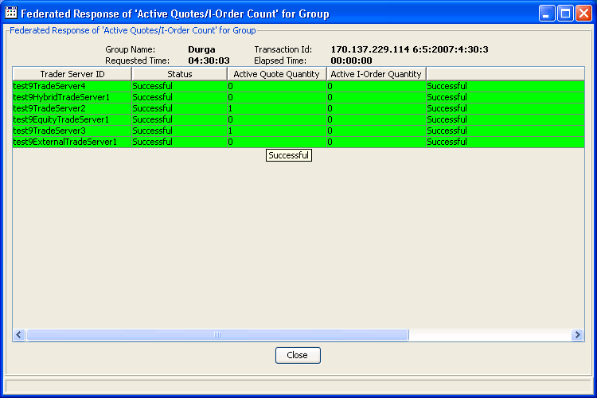
 | Select the close Button.one message window will get appear.select cancel if you don’t want to come out from the cancel quote window, otherwise select ok.

Exit the System

 | You can log out and exit the system at any time.
Exit the System | To exit the system, select Exit from the Start Menu. You will be prompted to verify that you wish to close all windows and logout. Click Yes. The application will be closed and you will be returned to your system desktop.

